**Screens for Week 4**

**EDA with Power BI: Wide World Importers DW**

Kimberly Sultan

4/14/19

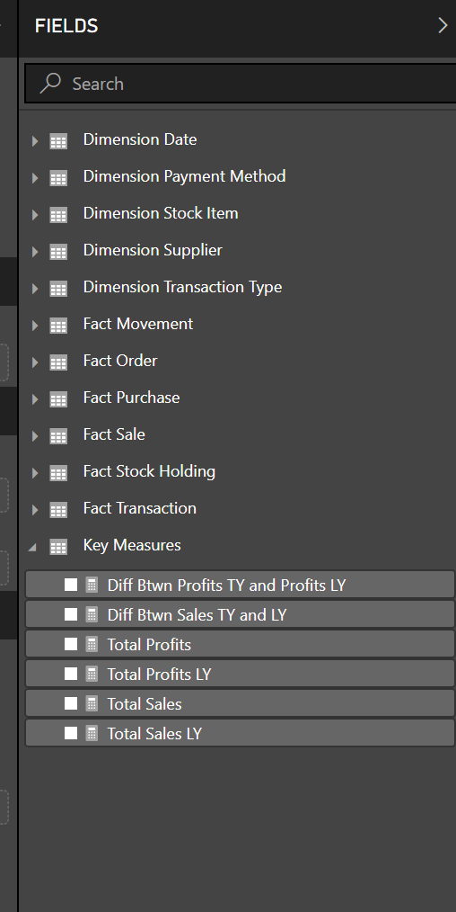

The tables imported from SQL Server WWI DW.

Key Measures Table is added here for Sales and Profits

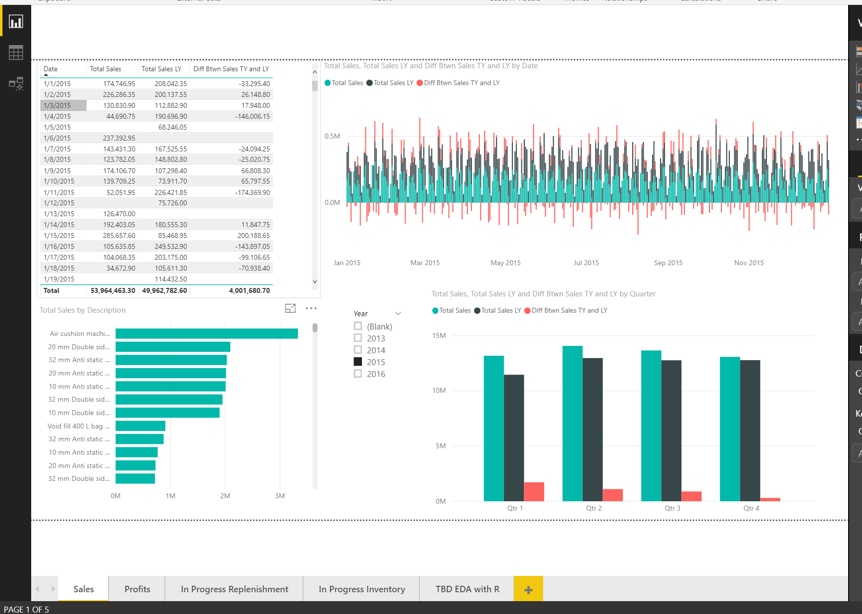

This is the Sales report to investigate Demand for Products.

The slicer is needed to select a Year and then this will compare the selected time period to the previous one. Total Sales by product description includes the top selling products.

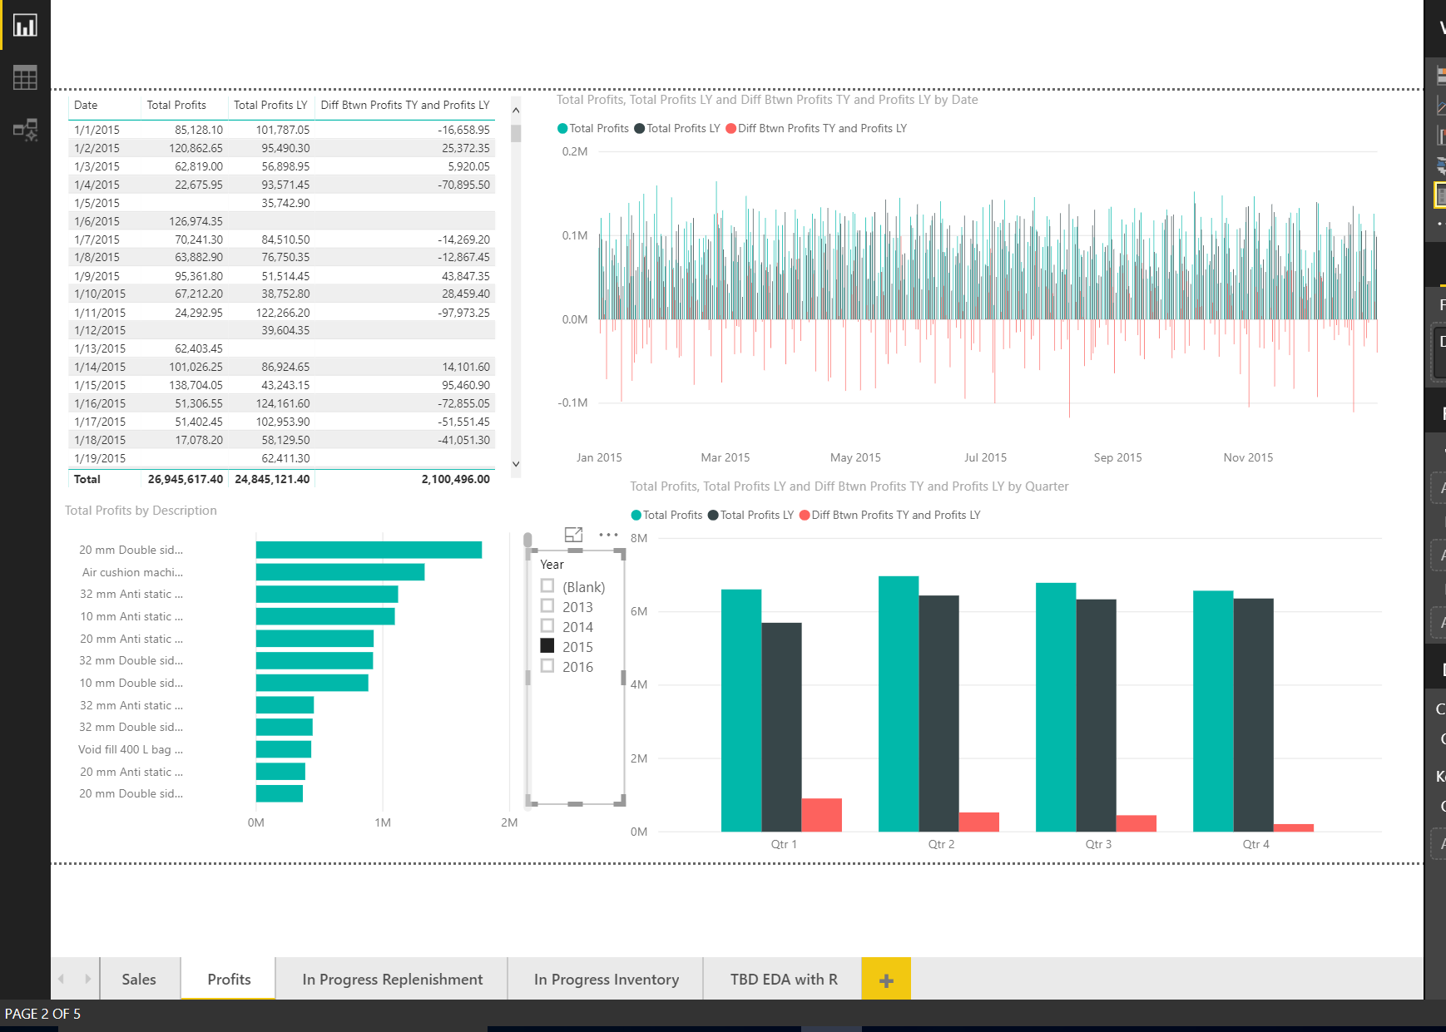

The profits report looks for trends in total Profits and comparing previous time periods. And organized like the Sales report.

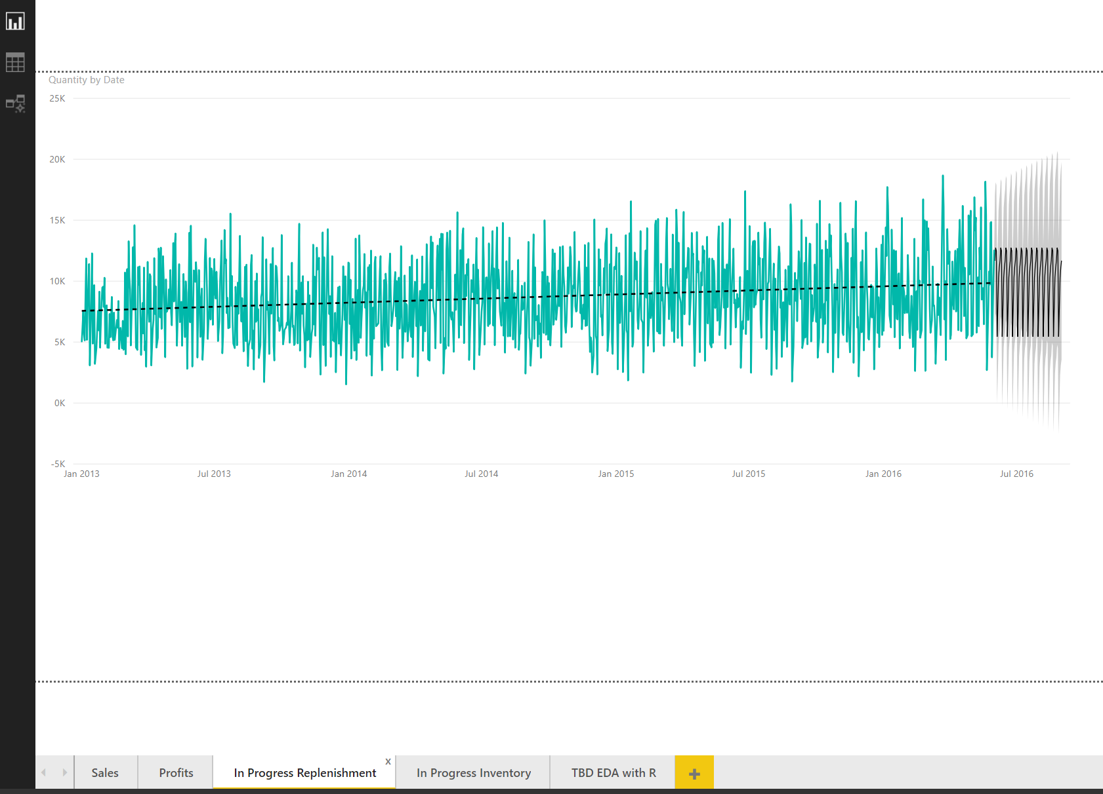

The replenishment report is in progress. This chart shows the Quantity data in the Order Table.

The forecast feature projects out 3 months.

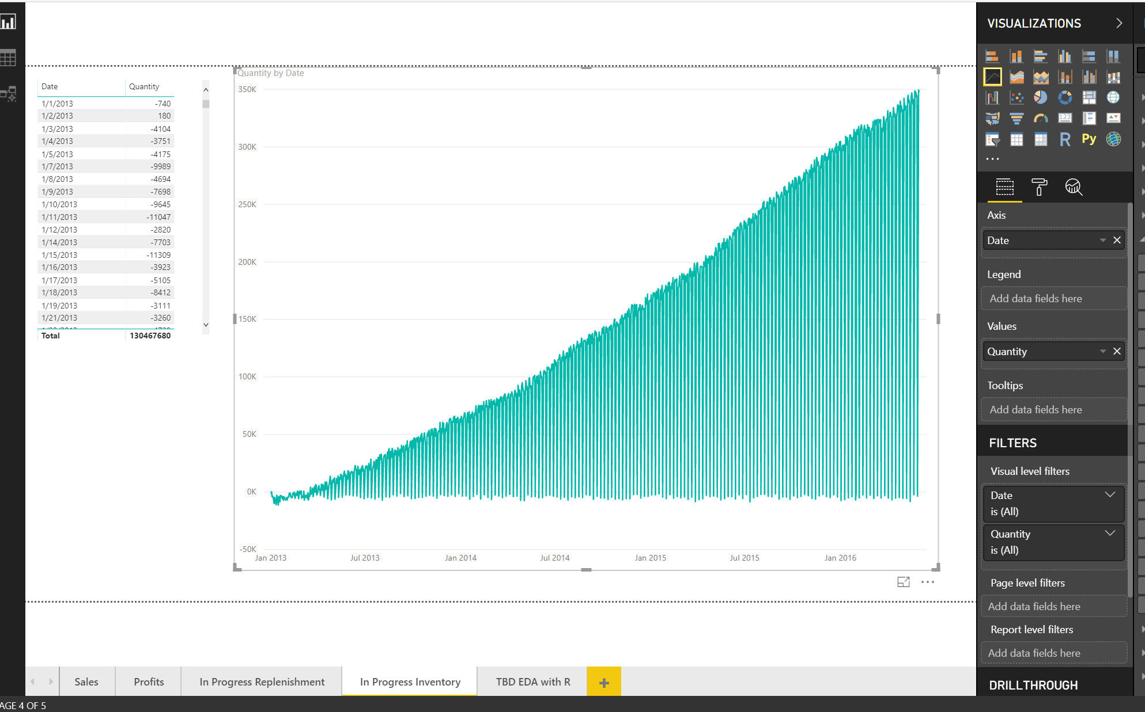This visualization is based on Inventory quantities by date. More exploration is needed to see trends. Overall inventory shows steady increase.

Additional measures to create:

* Inventory trends by top selling products.
* Inventory versus Sales line graphs.
* ROI